Non-Employee Appointments
Updated 04/04/2024

Non-employee appointments (e.g., courtesy, volunteers, ect.) are granted to individuals who have a relationship with the University, may require computer access, are designated volunteers, or otherwise have a role within our university community.
This manual explains the processes for departments in regard to non-employee appointments.
- Before creating a Non-Employee Appointment:
  - Is the Non-employee a current or previous employee or student?
    - If yes, collect information and then move to page 3 Current/Previous Employee or Student
    - If no, collect information and then move to page 5 NEW Non-employee (not current or previous employee or student)

- Information to collect:
  - Employee ID if applicable
  - First & Last Name
  - Appointees’s personal email address
  - Work Address
  - Appointee’s Home Address
  - File Attachments

- File Attachments
  - Forms can be found here: Nonemployee Appointments – Human Resources | Missouri S&T (mst.edu)
  - Staff Volunteer Sheet
    - Non-Employee Appointments must have a Staff Volunteer Sheet filled out and attached to the Hire ePAF. The only exceptions are Joint Appointments.
  - Courtesy Joint Appointment Agreement
    - ONLY for Joint Appointments
  - CV/Resume
    - For academic appointments and/or if it is declared on the Staff Volunteer Sheet that the Non-employee is not a United States Citizen.
  - Request for Approval of Non-Employee Appointment Form
    - If it is declared on the Staff Volunteer Sheet that the Non-employee is not a United States Citizen.
  - Invitation letter
    - For Visiting Scholar Non-employee appointments
  - OPT Card
    - For appointments where the person is being put on appointment on an OPT, the OPT card will need to be attached

- UM System Email Address
  - If a UM System email address is needed for the appointment, a request will need to be submitted AFTER the appointment is approved by HR, using the email account request form at: https://hr.mst.edu/position-management/nonemployeeappointments/

Current/Previous Employee or Student
- Login to hrprd.umsystem.edu
  - If you do not have access, please fill out the PeopleSoft Access Request form. It can be found here: HR Forms and Documents – Human Resources | Missouri S&T (mst.edu)

- Select the ePAF Homepage tile.

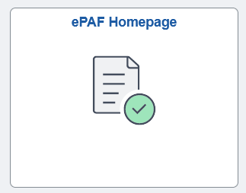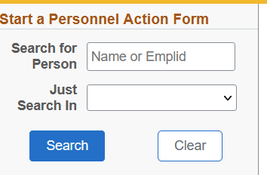

- In the upper left-hand corner of the screen, enter the Emplid number and click Search. If you do not have the Emplid search by Lastname,Firstname. Verify that the person you select is the correct person.
  - If the record shows that they are not a Current Employee, select the dropdown and choose Hire Non-Recruit
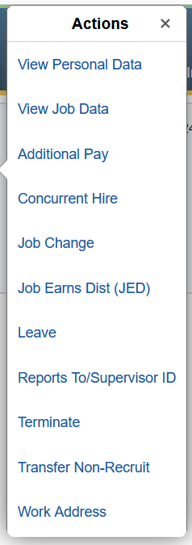
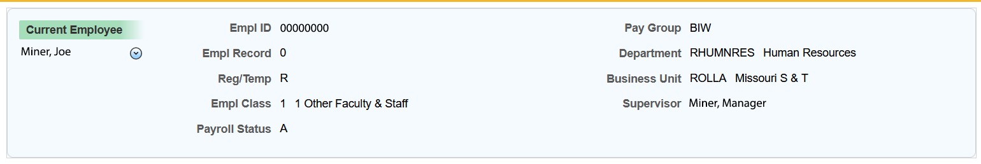
  - If the record shows that they are a Current Employee, select the dropdown and choose Concurrent Hire

- Make note of the Hire Form ID for tracking purposes. It will be listed in the top right-hand corner of the screen.

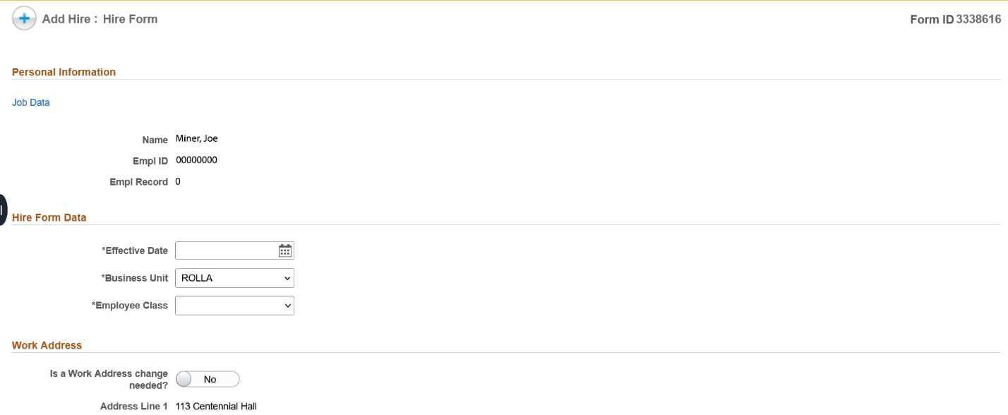

- Enter the following information:
  - Effective Date
  - Auto-Term & Appointment End Date
    - The max duration for Non-employee appointments is 1-year in length.
    - Requests for RARE exceptions on a case-by-case basis for longer than 1-year appointments may be made.
  - Business Unit- ROLLA
  - Position Number
    - This should be toggled to No, as there should not be a position number used for these appointments.
  - Supervisor ID
  - Department
  - Job Code
    - Select either 9993-COURTESY or 9996-VOLUNTEER
  - Working Title
  - Work Address
    - Address Line 1 should be the room and building number, Address Line 2 should be the street address
    - If the appointment is being created as a concurrent hire and will not be their primary appointment, do not change the work address unless the primary work location is changing. This is a fluid field and whatever is entered as the work address will also show up in the website directory.
  - Home Address
  - File Attachments- See page 2
  - Approve- See page 8 for next steps.
NEW Non-employee (not current or previous employee or student)
- Login to hrprd.umsystem.edu
  - If you do not have access, please fill out the PeopleSoft Access Request form. It can be found here: HR Forms and Documents – Human Resources | Missouri S&T (mst.edu)

- Select the ePAF Homepage tile.
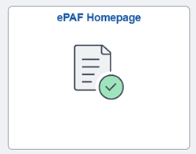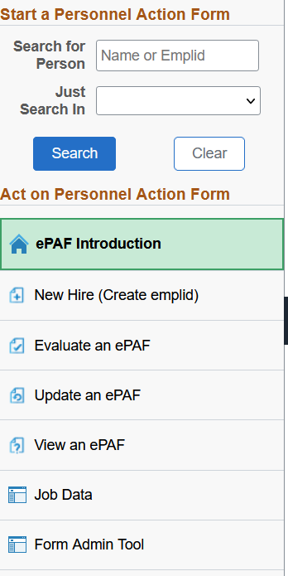

- Select New Hire (Create emlid)
- Make note of the Personal Bio-Demo Date Form ID for tracking purposes. It will be listed in the top right-hand corner of the screen.
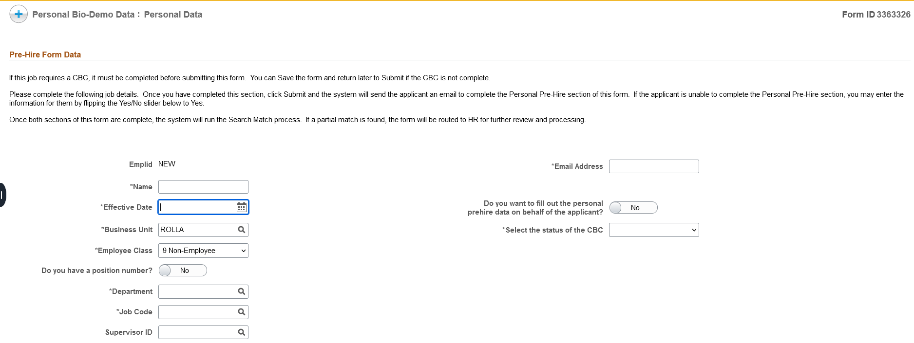
- Enter the following information:
  - Name
    - Make sure to use the legal First & Last name of the appointee.
  - Effective Date
  - Business Unit
    - ROLLA
  - Change the personal prehire data toggle as NO
  - Status of CBC should be Not Applicable
  - Employee Class should be 9 Non-employee
  - Change the position number toggle to No
  - Enter the department
  - Job Code
    - Select either 9993-COURTESY or 9996-VOLUNTEER
  - The appointee’s personal email address

- Approve?
- The appointee will receive an email prompting them to complete the demo data form. Once they complete the demo data, that form will be routed to Human Resources for review. After it is approved, you will receive two emails.
  - The first email informs you of the status of the DemoData form you submitted.
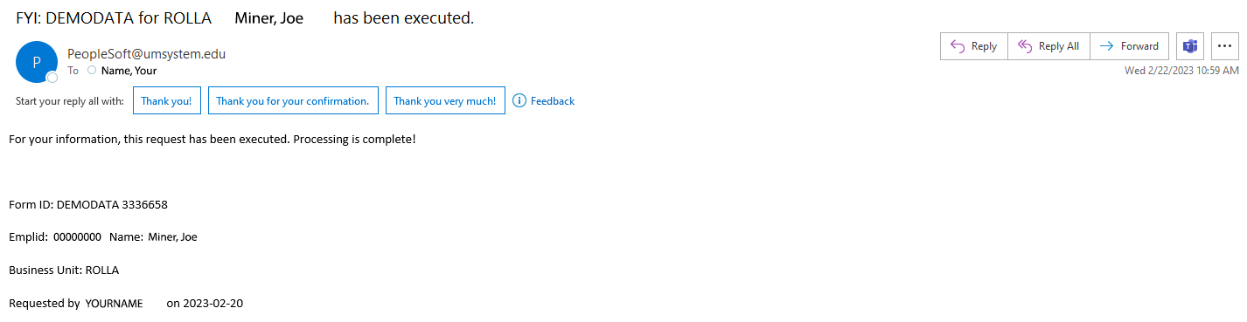

  - The second email informs you that your hire form is now ready for you to process.
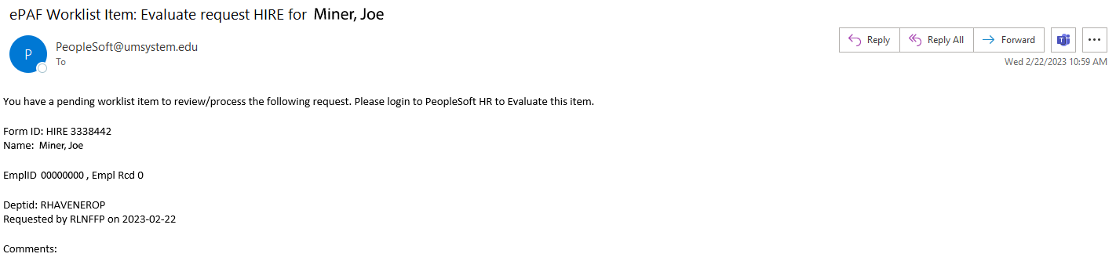
  - Make note of the Hire Form ID for tracking purposes.

- Log back into hrprd.umsystem.edu, select the ePAF Homepage tile, and then select Evaluate an ePAF.

- Enter the Form ID from the second email and Search.

- Enter the following information:
  - Effective Date
  - Auto-Term & Appointment End Date
    - The max duration for Non-employee appointments is 1-year in length.
    - Requests for RARE exceptions on a case-by-case basis for longer than 1-year appointments may be made.
  - Business Unit- ROLLA
  - Position Number
    - This should be toggled to No, as there should not be a position number used for these appointments.
  - Supervisor ID
  - Department
  - Job Code
    - Select either 9993-COURTESY or 9996-VOLUNTEER
  - Working Title
  - Work Address
    - Address Line 1 should be the room and building number, Address Line 2 should be the street address
    - If the appointment is being created as a concurrent hire and will not be their primary appointment, do not change the work address unless the primary work location is changing. This is a fluid field and whatever is entered as the work address will also show up in the website directory.
  - Home Address
  - File Attachments- See page 2
  - Approve- See page 8 for next steps.

Next Steps
- After you submit the Hire ePAF, the form will be routed to HR for approval. They will do one of three things.
- Approve
  - If all sections are filled out, the correct attachments uploaded, and all other processes have been completed, the Hire ePAF will be executed.
- Recycle
  - If there is missing information, HR will recycle the form back to you with a comment about what information is missing.
  - Enter the missing information and resubmit the form.
- Hold
  - The form has been put on hold while there is an export control review completed by the compliance team.

- You can check the status of a form by logging in to hrprd.umsystem.edu, select the ePAF Hompage tile, select view an ePAF, enter the Hire Form ID and Search.
  - Scroll to the bottom and click next.
  - Click on the Signature/Action Logs drop down and see that the last Form Action is.

- If your form is in Recycle or Hold status for longer than one week, you can reach out the Non-employee Appointment HR representative with the Hire Form ID. If a form is in “limbo” for too long, the system may auto withdraw the Hire form. You would then have to complete a new Hire ePAF.

- Your department will receive a monthly email with a list of all the current Non-employee appointments in the department and their Auto Term dates.

  - If your department would like to extend the appointment, they/you will need to submit a new Hire ePAF to reappoint them.
    - The effective date on the new ePAF should be the same date or later date than the current Auto Term date.
    - Reappointments should not be submitted more than two weeks prior to the term date
  - If there is someone on an appointment that no longer needs one, please go ahead and submit a termination ePAF for them.

